|  |  |
| --- | --- |
| Name: Aswad jamal | EE-272L Digital Systems Design |
| Reg. No.: 2023-EE-84 | Marks Obtained: ____________ |

C:\Users\Admin\AppData\Local\Temp\ksohtml5912\wps1.png

|  |  |  |  |  |  |
| --- | --- | --- | --- | --- | --- |
| **DSD Lab Manual Evaluation Rubrics** | | | | | |
|  |  |  |  |  |  |
| **Assessment** | **Total Marks** | **Marks Obtained** | **0-30%** | **30-60%** | **70-100%** |
| Code Organization (CLO1) | 3 |  | No Proper Indentation and descriptive naming, no code organization.  Zero to Some understanding but not working | Proper Indentation or descriptive naming or code organization.  Mild to Complete understanding but not working | Proper Indentation and descriptive naming, code organization.  Complete understanding, and proper working |
| Simulation (CLO2) | 5 |  | Simulation not done or incorrect, without any understanding of waveforms | Working simulation with errors, don't cares's(x) and high impedance(z), partial understanding of waveforms | Working simulation without any errors, etc and complete understanding of waveforms |
| FPGA (CLO2) | 2 |  | Not implemented on FPGA and questions related to synthesis and implementation not answered. | Correctly Implemented on FPGA or questions related to synthesis and implementation answered. | Correctly Implemented on FPGA and questions related to synthesis and implementation answered. |

**Lab Manual**

**Task no 1**

When we apply 5V volt at terminal A, the voltage at terminal B is 0.04V and the LED does not glow.

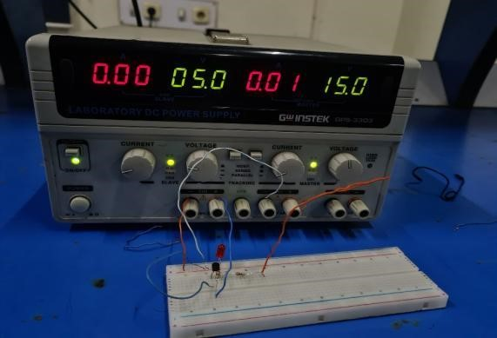

**Task no2**

When we apply 0V volt at terminal A, the voltage at terminal B is 2.2V and the LED does glow.

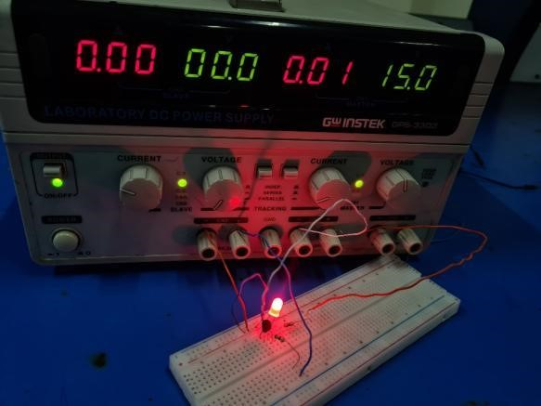

**Task no 3**

Applying a 5V peak, 1kHz square wave to terminal A. The propagation delay is 68 microseconds.Initially, the delay appears to be negligible.

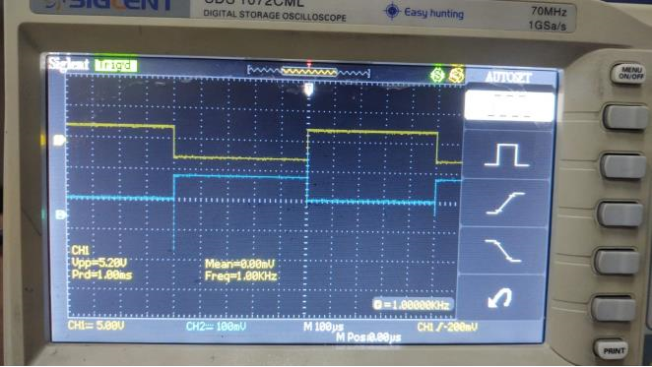

**Task no 4**

When applying 5V peak,100kHz square wave at terminal A. The propagation delay is 80 microsecond

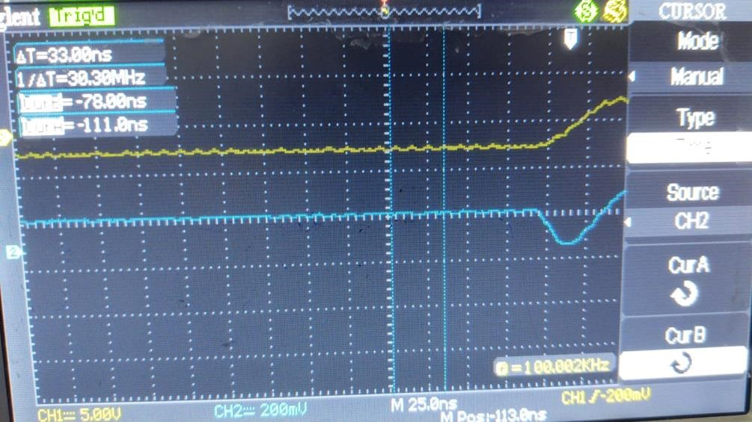

**Task no 5**

At high frequencies, the MOSFET is unable to transition quickly between on and off states due to gate capacitance. This causes the output signal to change more slowly and with fewer sharp edges. The output voltage may not fully reach 0 V, resulting in incomplete switching.